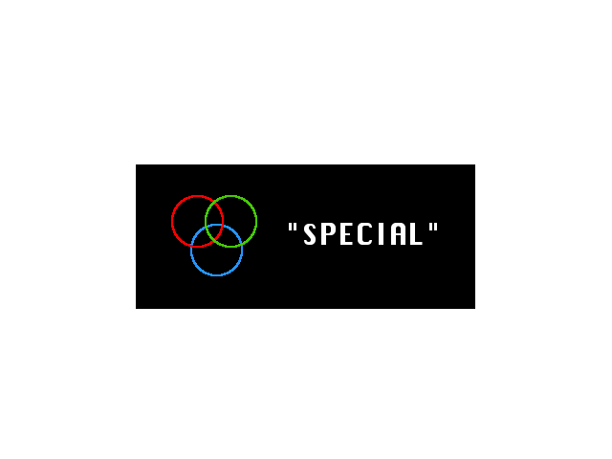

W

Restart Level

BLUE

**ESC**

**DOWN**

**RIGHT**

**LEFT**

**UP**

GREEN

L

K

J

I

RED

D

S

A